FaceAge2 Full PRD (11.19) - $2,000

**What is FaceAge**?

FaceAge2 is a filter that converts a 2D face into a 3D head, allows rotation of the head, changing age or weight and adding/removing smile. Code is based on existing app. It works transparently over the existing photo.

**What does transparent mean**?

When launched, FaceAge operates on a transparent (png) layer, so that the Photoshop user does not perceive it as another application, even though it is the HeadShop app running on a transparent layer. (no borders or scrollers)

**What is the end result**?

Once user makes change to head, FaceAge closes and places a 2D image of the result on a new Photoshop layer

**Steps:**

1. Photoshop is opened with an image. FaceAge is launched from under the Filter menu.

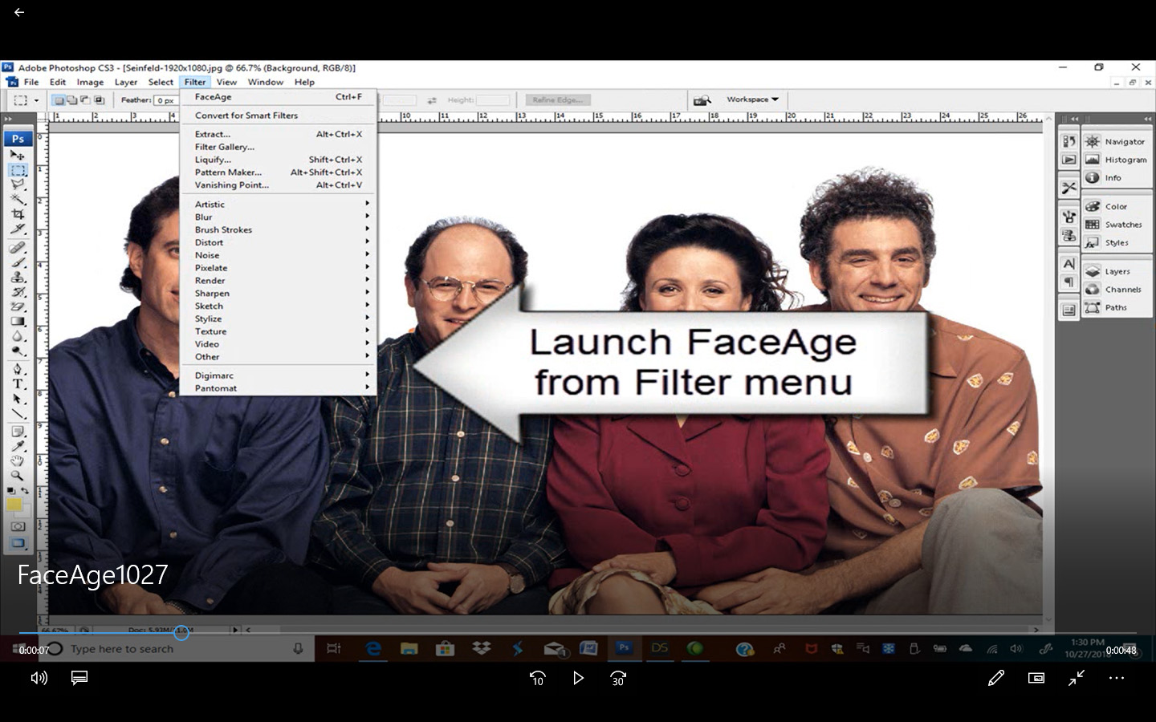

1. FaceAge loads in on a transparent layer. When user click on a head, a yellow box is placed. 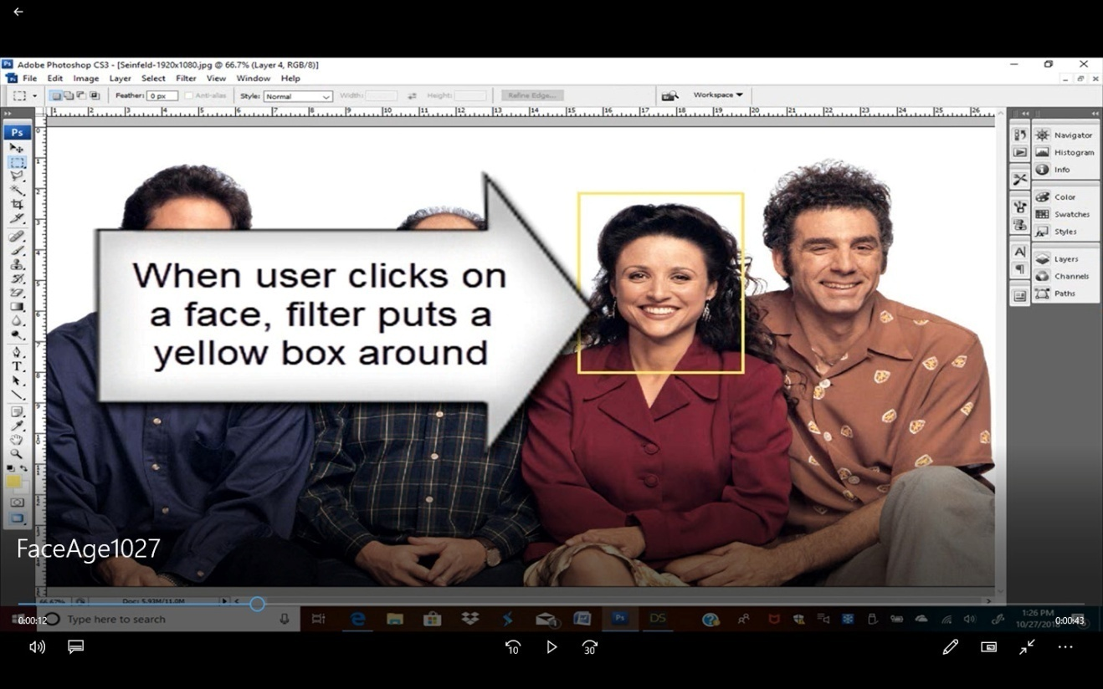
2. After 10-20 seconds two things happen; the 3D head is placed on a transparent layer, exactly on the right size/location. (This is the trickiest part – how to detect Photoshop screen size, magnification). Invisible layer allows for 3 axis rotation via the mouse or touch. The slider dialog floats above. (for “behind the scene/invisible to user see ADDENDUM).

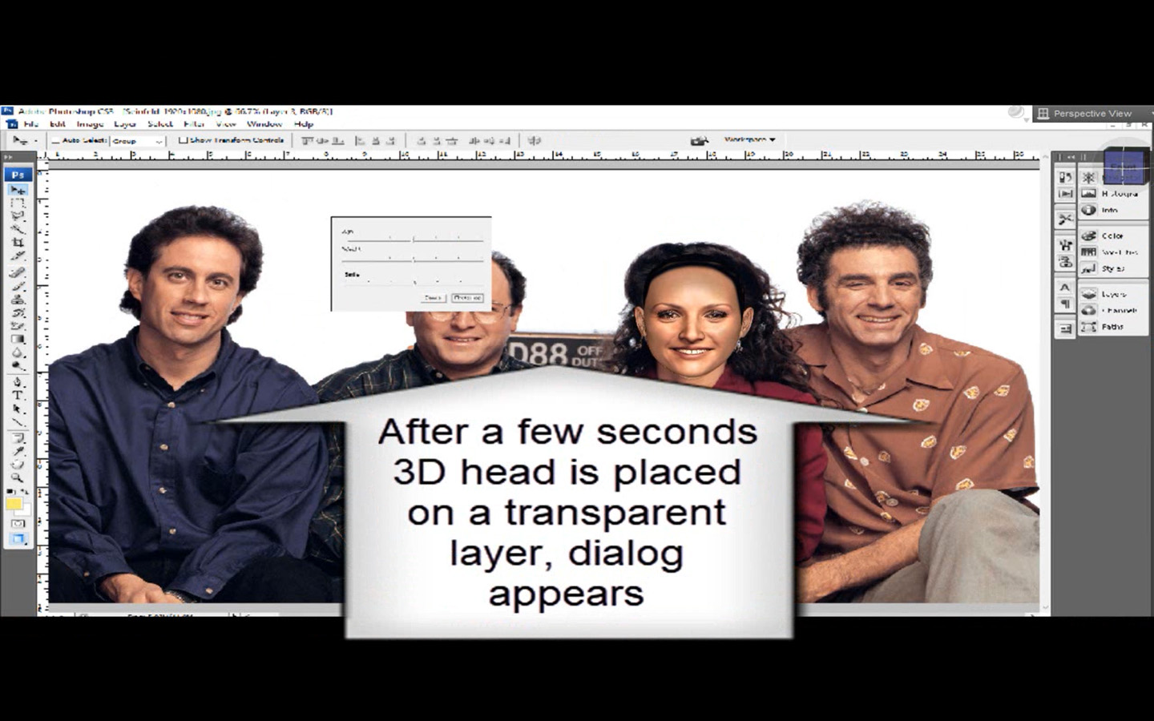

1. About sliders – small change. All sliders default to 50% position. Age slider also shows 50%, which is the adult position. Moving the slider right will morph toward “Old”, moving the slider left will morph toward ” Child”. Note: there is no Male or Female child, only “Child” (which is female).

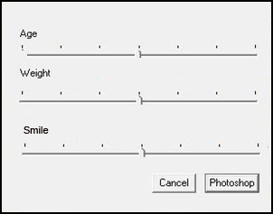

1. User can rotate head on the transparent layer in 3 axes (similar to Printahead cloud app). Also, user can use sliders to add age, weight, smile, etc.

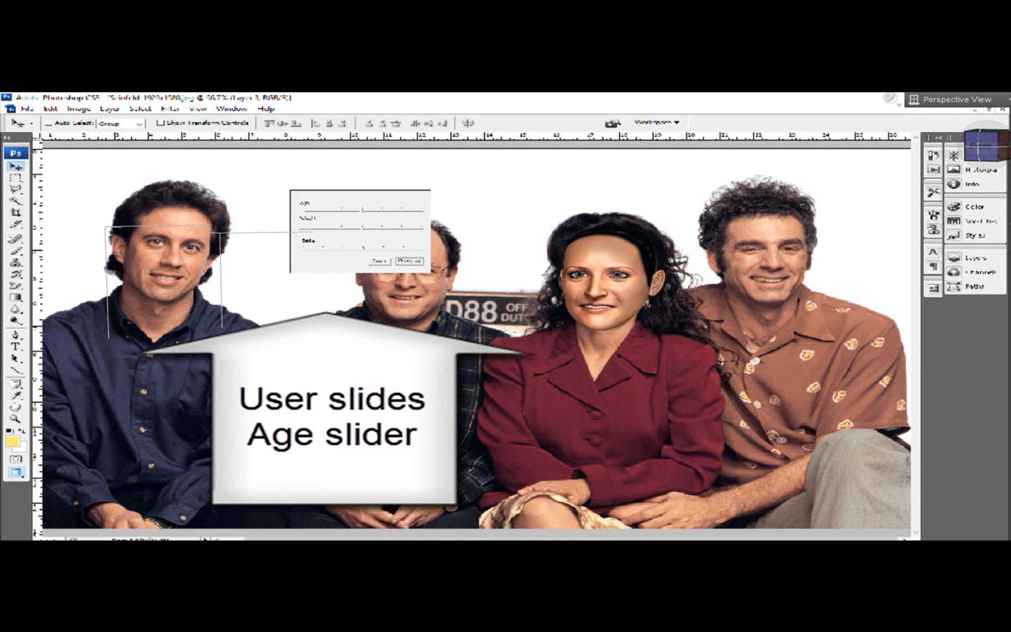

1. When user happy, clicks on Photoshop button and the 3D head is copied as a 2D image onto a transparent layer via the clipboard. FaceAge shuts down and the 2D head appears in a separate layer . User can toggle between before/after by turning off new layer.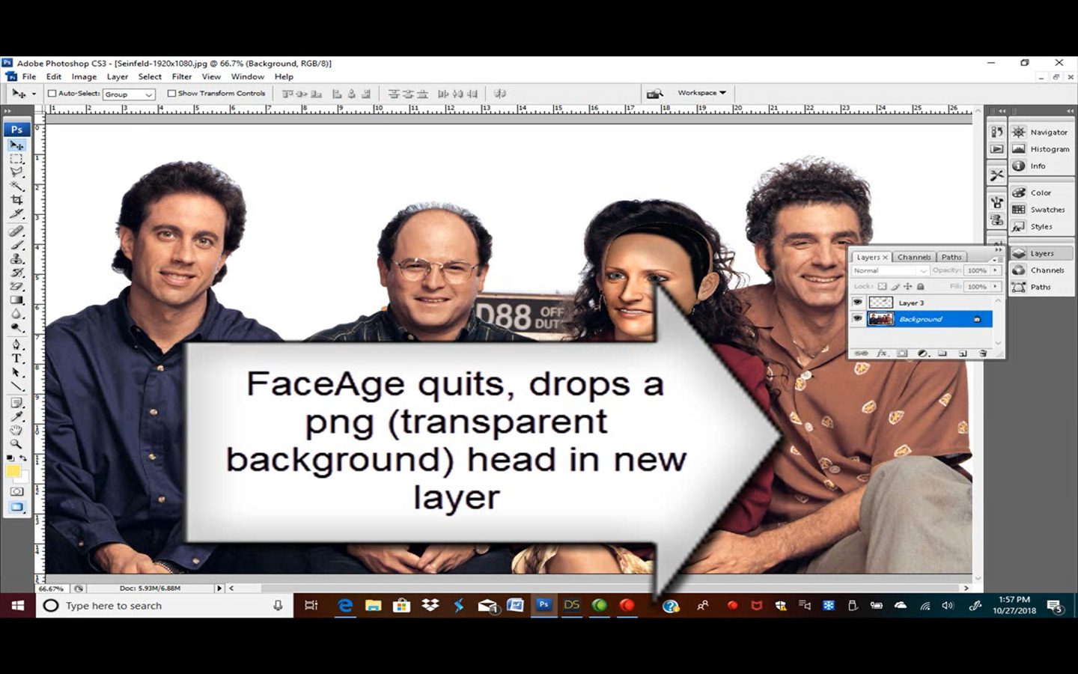

ADDENDUM

Explanation of process of going from Step 1. to Step 3. Process is based on the already existing OneClick2 process/code which runs “behind the scene/invisible to user”.

1. When user launches FaceAge, an auto face-detect code indentifies faces on the photo.

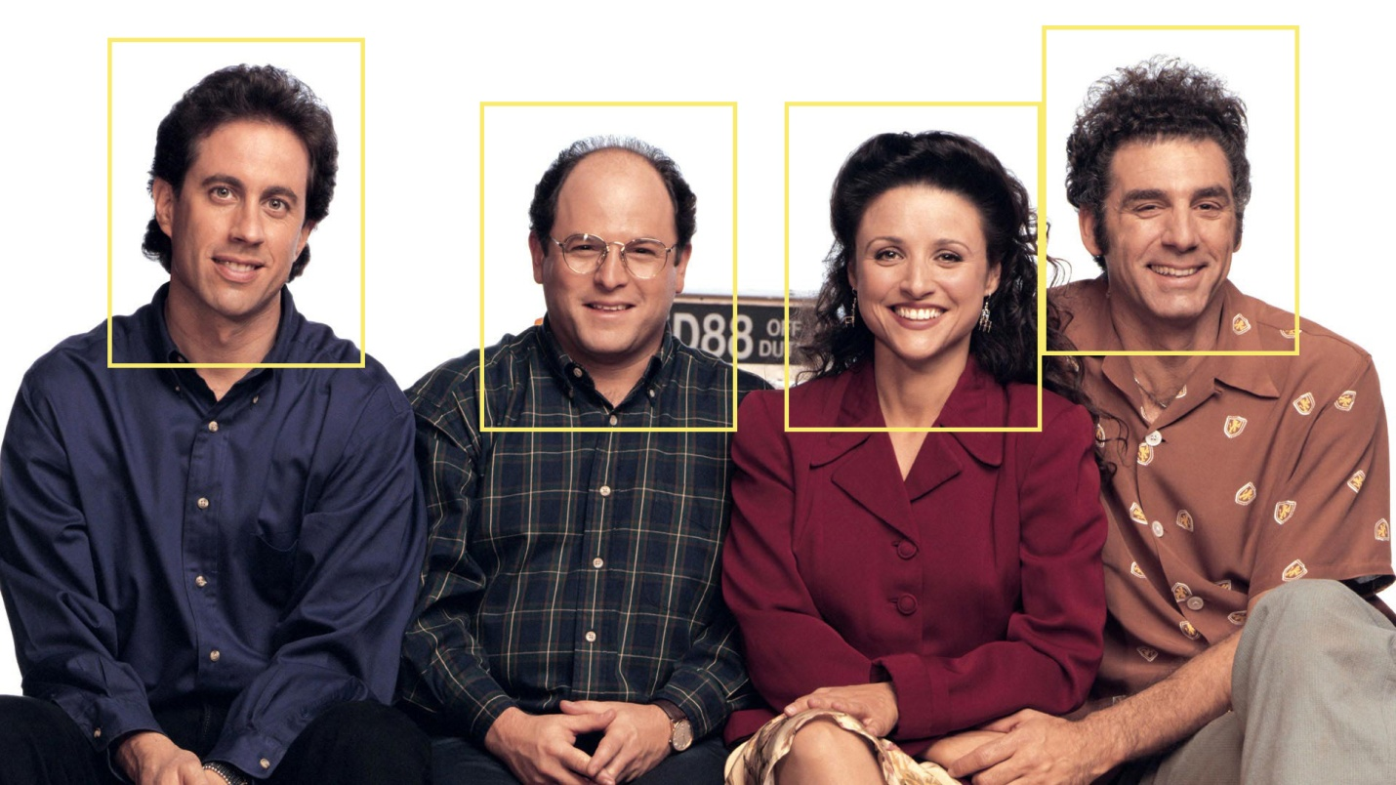

1. User clicks on the person he wants to work on. App will copy parts of the photo that is inside the yellow box onto the clipboard and transfers it to OneClick setup (Invisible to user). Here autodots are placed and gender auto-select performed.

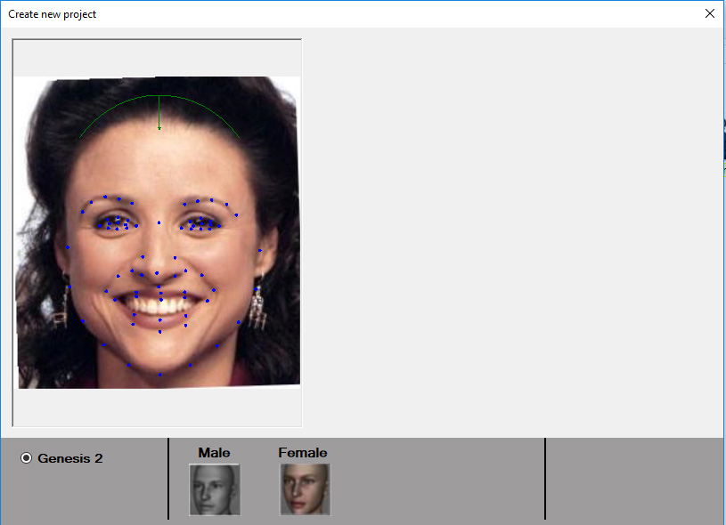

1. OneClick performs 3D generation and produces a 3D head with texture and rotated to coincide with the head rotation on the picture. Continue in Step 3.